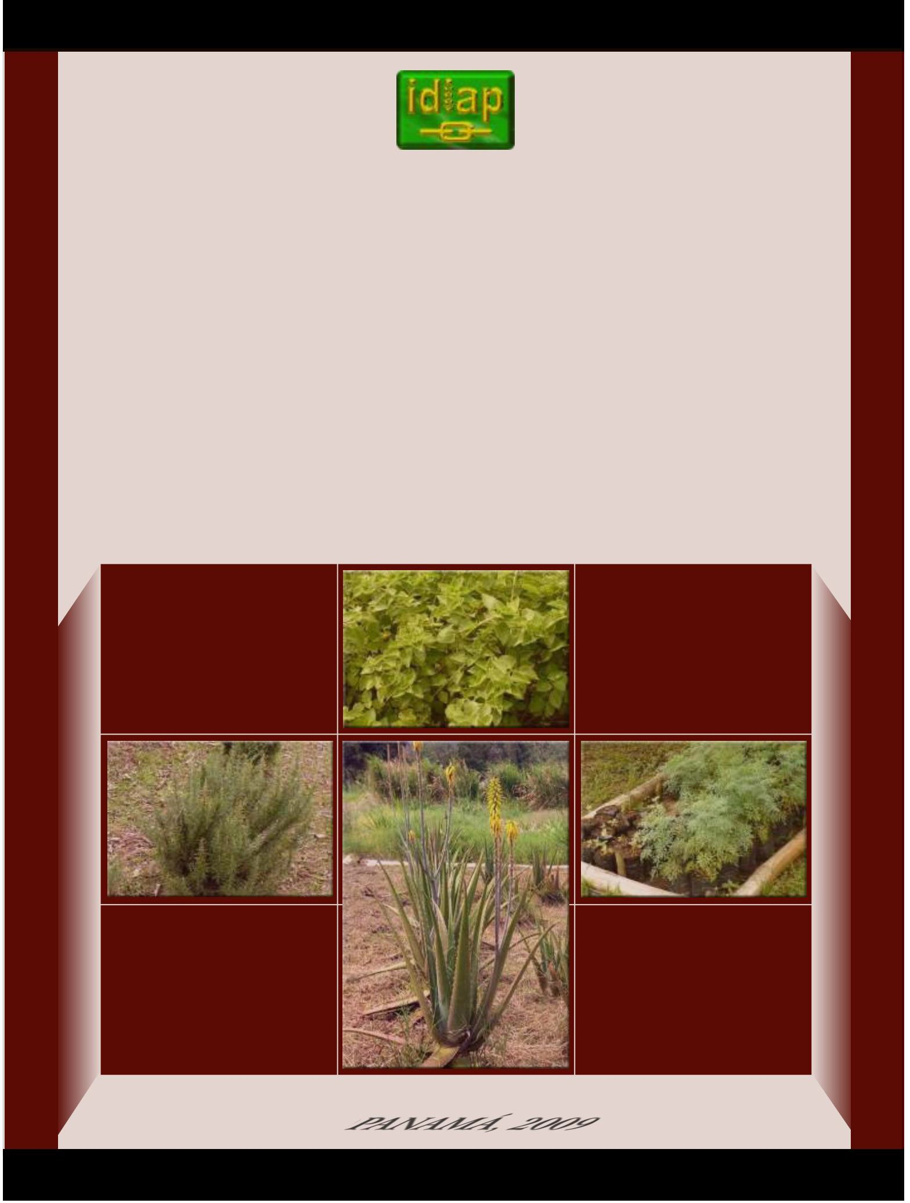

INVESTIGATION INSTITUTE AGRICULTURE OF PANAMA

MEDICINAL PLANTS COLLECTED IN PANAMA

PANAMA, 2009

INVESTIGATION INSTITUTE AGRICULTURE OF PANAMA

MEDICINAL PLANTS COLLECTED IN PANAMA

omar alfaro

PANAMA, 2009

MEDICINAL PLANTS COLLECTED IN PANAMA

Agricultural Research Institute of Panama.
Department of Editions and Publications.

Panama, 2009
p.28 illus.13

ISBN: 978-9962-677-03-1

Board of Directors

Ing. Olmedo Espino
Minister of Agricultural Development President

Ing. Roberto Jimenez Dr. Julio Escobar V., Ph.D. Dr. Juan Miguel Osorio, Ph.D.

General Manager of the Bank of
Agricultural Development Member
National Secretary of
Science, Technology and Innovation Member
Dean of the Faculty of
Agricultural Sciences
Member

Dr. Jorge Aued H.
Managing Director Secretary

Board of Directors
Dr. Jorge Aued H.
Managing Director

Ing. Benjamin Name, M.Sc.
Deputy General Manager

Ing. Franklin Becerra B., M.Sc.
General secretary

Dr. Julio Santamaría Guerra, Ph.D.
National Director of Research Centers

Ing. Carmen Y. Bieberach, M.Sc.
National Director of Agricultural Research

Dr. Manuel De Gracia, Ph.D.
National Director of Livestock Research

Ing. Emigdio Rodríguez Q., M.Sc.
Western CIA Director

MV Melvin Espino
Director of the CIA Azuero
Ing. Ladislao Guerra M., M.Sc.
National Director of Products and services

Lic. Luz Graciela Cedeño
National Director of Administration and finance
Ing. Maximino Batista
Director of the Central CIA

Ing. Andres Acosta
Director of the Humid Tropics CIA
MV Victor Escudero
Director of the Eastern CIA a.i.

Ing. Pío Tuñón
Director of the CIA-Genetic Resources

Machine Translated by Google

Contents

INTRODUCTION
COLLECTION. two
NURSERY MULTIPLICATION. 2
METHODS OF PROPAGATION OF MEDICINAL SPECIES. two
Sowing by seed. 2
Propagation by cuttings or stem sections. 3 Multiplication
by layering. 3 Multiplication by
children 4 Multiplication by
rhizomes. 4
FIELD ESTABLISHMENT OF GERMPLASM BANK
(COLLECTION OF WORK). 4
CHARACTERIZATION. 4
RESULTS. 5
PRELIMINARY CHARACTERIZATION OF COLLECTED SPECIES. 5
CAROB TREE. 5
ALOE 6
CITRONELLA. 7 LEMON
GRASS. 8
MINT. 9
GUARUMO. 10
GUAVA. 10
GOOD GRASS. eleven
PLANTAIN. 11
ANAMU. 12
MASTRANT. 13
ROSEMARY. 13
RUE. 14
OREGANO. fifteen
CONCLUSIONS. 16
BIBLIOGRAPHY. 16

Machine Translated by Google

MEDICINAL PLANTS COLLECTED IN PANAMA

INTRODUCTION
Omar Alfaro1

Panama has a very wide flora, it is estimated that there are about 10,000 plant species nationwide, most of which have not been investigated to identify their usefulness, so the potential that exists
in the Panamanian flora, of species that can represent a market opportunity, as a raw material for its industrialization or as a finished product, with the consequent benefit of the added value in its processing.

Some species of plants are used by a sector of the population for the treatment of some common diseases, especially in the rural population, which sees limited opportunity to use the national health system, taking great value in the use of this type of method. alternative, mainly in the indigenous ethnic groups, who have a great wealth of cultural knowledge on this subject.

Documentation at the national level, scientifically supported, on the identification of species, their characteristics, agronomic management and the traditional use of medicinal plants is limited, generating the need to document these issues to reduce the risk of loss of popular knowledge about the resources of our forest.

In many countries, information on the use of plant species in medicine is systematized and rests on documents formally registered as part of the corresponding Pharmacopoeia, which includes the description of the resource and mainly information on the properties they possess.

The international literature has a large number of documents on the use of medicinal plants, which lack a scientific basis for the properties that the aforementioned species actually possess, attributing to them, in most cases, healing properties, which deserve a reserved opinion. about its veracity.

There is a clear delimitation of the information related to the topic of medicinal plants, which is located in the topics of a) taxonomy, which corresponds to its botanical identification; b) agronomic management according to the needs of each species to achieve adequate levels of quality and quantity of active ingredients; c) pharmacology, which includes the study of the active principles
of each species and d) therapeutics, which deals directly with the form of use of each species.

Some of the accessions that are part of the collection of the Research Institute
Agricultural (IDIAP), are frequently identified with names of species that have their space in the international market of medicinal plants, however, their botanical classification does not correspond to the species referred to, specific case of Salvia
Pluchea carlinensis (Jacq), a shrub species that is commonly used by the population

1M.Sc. NRM. IDIAP. Agricultural Research Center on Genetic Resources CIARG, e-mail: omar04alf@gmail.com

for the relief of neuralgia, its classification does not correspond to Salvia officinalis, a species commercialized internationally, to which other types of uses are attributed; Another particular case is the Tilo Justicia pectoralis, a semirastrera herb that is used as a relaxant and nervous calmer in the Central American and Caribbean region. It is totally different from the shrub species Tilia platyphyllo, from a temperate climate, which is commercialized internationally (Roig1988).

This and other cases indicate the need to scientifically guide the study of the species that are reported to have medicinal properties, beginning with the botanical characterization, in order to offer interested producers the opportunity to cultivate and market those that have a recognition in the global market.

The IDIAP has a working collection of 40 species, reported to have medicinal properties, which are being botanically characterized, to subsequently proceed to the generation of the necessary agronomic information, to provide technical support to the cultivation of those with greater market potential.

The objective of this work is to collect, characterize and multiply genetic material of medicinal plants, to generate information on the general characteristics of these species, in such a way that there is a cognitive base that allows the promotion of their cultivation.

The phases developed by this research project were the following:

COLLECTION

This phase included the acquisition of genetic material, which was carried out by different methods:
a) exchange with other organizations or people, b) collection of materials obtained on field trips, and c) purchase of plants in nurseries.

NURSERY MULTIPLICATION

The multiplication of the species is carried out continuously, to guarantee the availability of genetic material that allows the regeneration of the species, conserving its main DUS characteristics (Different, Homogeneous and Stable).
The multiplication is carried out using the most suitable methods for each species, either by seed, suckers, stem sections or cuttings, layering or planting of rhizomes.

PROPAGATION METHODS OF MEDICINAL SPECIES

The methods used successfully in the project for the propagation of plants in collection are described below:

sowing by seed

This is the most frequently used method for species that produce floral structures and viable seeds, which can be used to obtain populations that allow their massive propagation (Figure 1).
This type of seed can be obtained in parcels destined for this purpose or in trade,

two

from certified seed producing houses.

Propagation by cuttings or stem sections.

A considerable number of species are multiplied in this way, mainly due to the absence of floral structures and/or viable seeds, proceeding to obtain
cuttings, cuttings or stem sections that are planted in germinating trays with
substrates prepared for this purpose (Figure 2).

Some species such as Rosemary (Rosmarinus officinalis and Yerba mint (Mentha citrata), presented a better response when using herbaceous sections of the stem, however others, of a bushy type such as Mastranto (Lippia alba), require the use of sections of stem or cuttings with marked wood formation, in it, so that an adequate margin of regeneration of the seedlings can be obtained.

Figure 1. Certified seed of different species of medicinal plants.

layer multiplication

This method is used for the multiplication of species which have a fairly long juvenile life (5 years or more), in which the tree or shrub does not form floral structures for the production of fruits.

This method consists of a ringed cut of the stem at the level of the productive branches of an adult plant, which is treated with growth regulators that
promote root formation, covering it with a generally
inert substrate, until the formation of roots, to cut the stem. stem immediately below section

Figure 2. Multiplication of species medicinal through cuttings or stem sections.

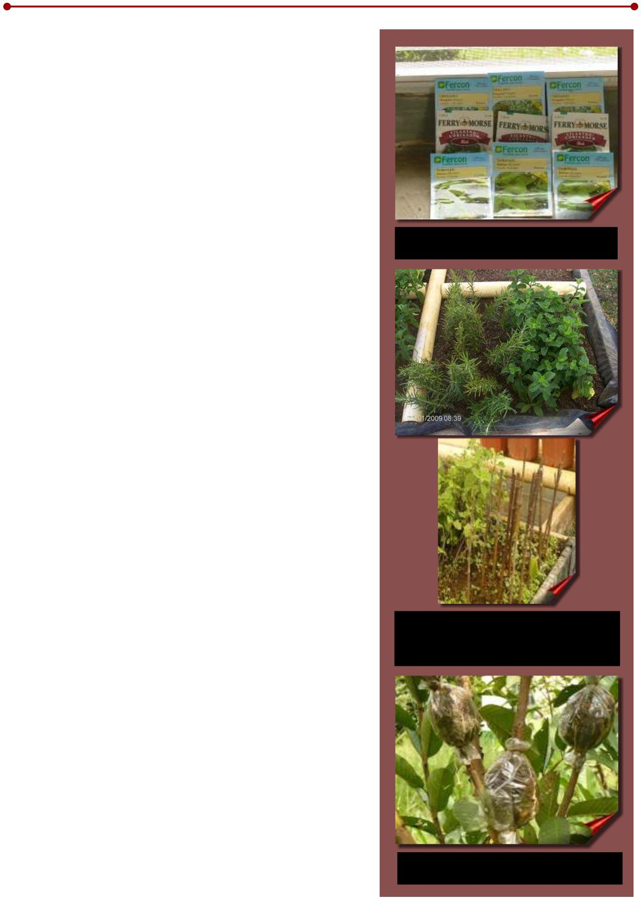
rooted, to be later planted in cartridges, or pots for acclimatization (Figure 3).

Figure 3. Air layering in guava
Psidium guajava.

3

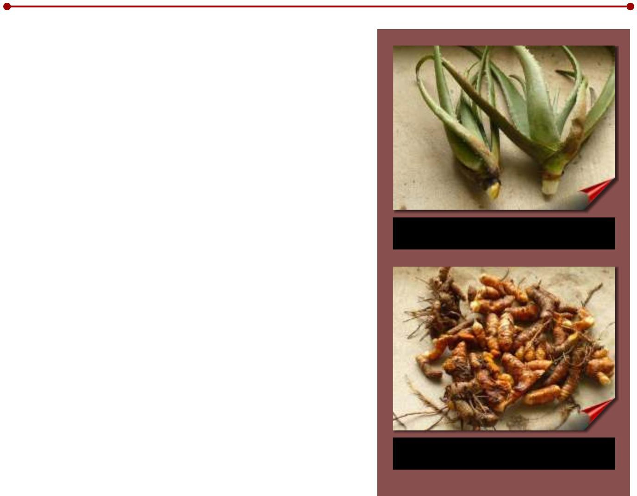
multiplication by children

The system of multiplication by offspring is used in species with herbaceous growth, which do not produce viable seeds, but which emit seedlings dependent on the mother plant, which allow their multiplication.
Example: Aloe barbadensis Aloe (Figure 4).

multiplication by rhizomes

The rhizomes are vegetative structures that contain an appreciable amount of buds or meristematic points, with a high regeneration capacity, which are used by producers as seed for planting commercial plots (examples: ginger
Figure 4. Children of aloe Aloe barbadensis,
for planting.

Zingiber officinale, turmeric Curcuma longa)
(Figure 5).

All the aforementioned methods were used for the multiplication of the species that are in the collection, using the most convenient for each one,
significantly reducing the percentage of mortality
of the seedlings.

Figure 5. Curcuma rhizomes
(Curcuma longa), for planting.

ESTABLISHMENT IN FIELD OF THE BANK OF GERMPLASM (WORKING COLLECTION)

In this phase, they were installed in field plots, with a minimum size of 10m in order to maintain these plots as a primary source of seed for the species in collection.
two ,

Some species that are arboreal growth are part of the collection, which are found as part of the spontaneous natural vegetation in different parts of the farm and that are also used as a source of seed to obtain a greater number of individuals. .

CHARACTERIZATION

In this phase, we proceeded to identify the main phenotypic characteristics of the species in the collection and consult bibliographic material, in order to have a documented reference for each species. Among the main characteristics recorded, we can mention the type of growth, plant height, shape, size, position and color of the leaves, coloration and shape of the stem, floral structures, flower color, hairiness, seed production and others. .

RESULTS

To date, it has been possible to collect 40 species that are referenced with some medicinal property, which have been subjected to propagation processes, using planting methods that have shown greater efficiency in plant regeneration.

There is a working collection, which is constituted in the Germplasm Bank of medicinal species, which is subject to periodic renewal, every five to six months, in such a way as to maintain the best characteristics of the propagated material.

The preliminary characterization of the collected species has begun, to achieve their full identification, in such a way as to generate sufficient information for the promotion of these items of great commercial and economic potential.

PRELIMINARY CHARACTERIZATION OF COLLECTED SPECIES

Below is information on the preliminary characterization of some of the species collected, as a result of the observations made at the Experimental Ollas Arriba farm, in addition to a reference bibliographic component on the subject, in such a way as to have a cognitive base of the characteristics botanical and agronomic characteristics of the species under study.

CAROB TREE

Scientific Name: Hymenaea courbaril L.

Family: Leguminosae

Tree that can reach up to 20 m in height, densely branched. The leaves are bifoliate (there are two leaves on the same petiole), alternate, ovate-elliptic in shape, with entire edges, hairless and shiny on the upper face, with the particularity of having complete leaf veins (Roig1988; FACT1998 ).

The fruit is a flattened pod, 7 to 14 cm long, dark brown in color and containing 4 to 6 seeds embedded in an opaque yellow pulp, with a sweetish taste and an odor characteristic of this species.

It is reported that the pulp that contains this legume is of a high nutritional value that in the first stages of the plant is bitter and then acquires a sweetish flavor (Navarrete and Orellana 1998; Francis 1990).

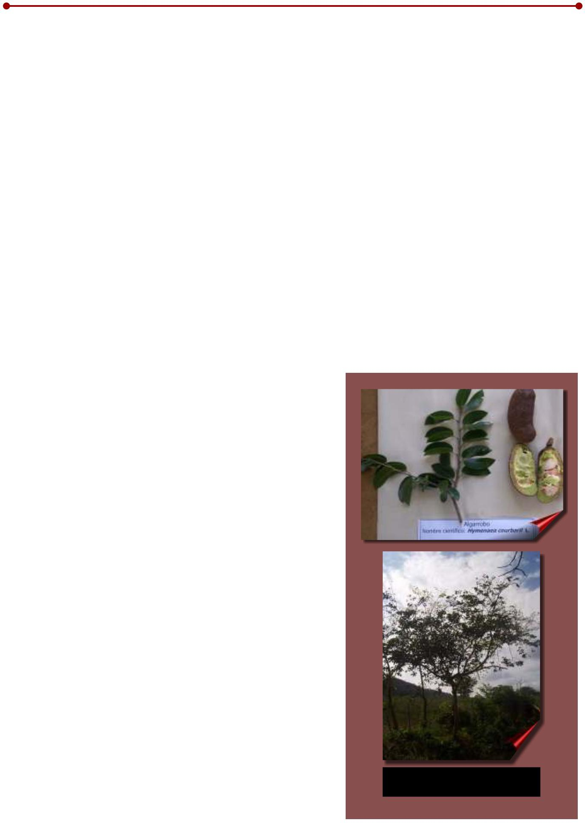
Trees of this species can be found in ecologies of Tropical Humid Forest and Forest
Dry Tropical, with its range of adaptation from sea level to 900 meters above sea level and rainfall ranging from

Figure 6. Carob tree
(Hymenaea courbaril L.).

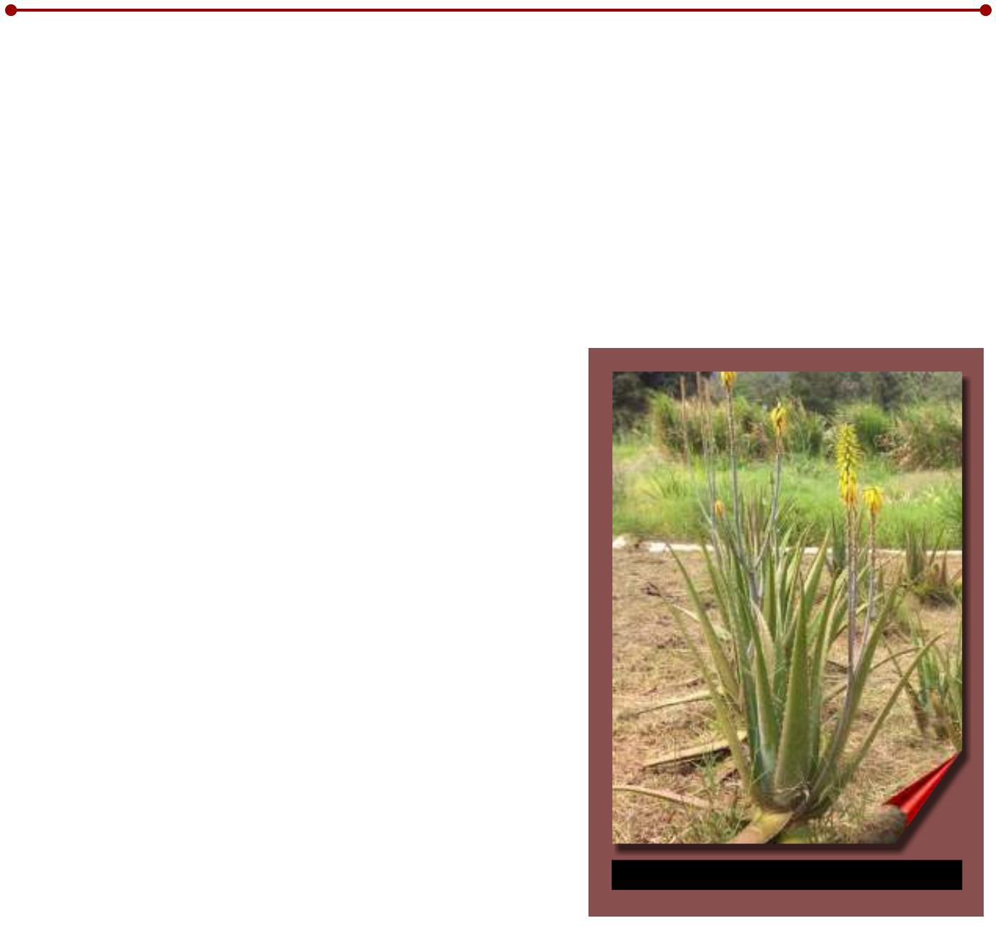
1,200 to 2,150 mm per year (Navarrete and Orellana 1998).

The wood of this tree is highly valued for its color and high density (Navarrete and Orellana 1998).

Beneficial effects are attributed to this species for the relief of kidney problems, for which the bark is used, cut and washed, and subsequently placed in water, which is taken as tap water (Navarrete and Orellana 1998).

ALOE VERA

Scientific name: Aloe barbadensis Mill.
Family: Liliaceae.

It is an acaulescent plant (it does not form a true stem), with leaves 0.60 m long and an average width of 0.08 m, light green, rosette-shaped, fleshy, with margins provided with separate teeth or spines of non-lignified tissue. from 2 to 2.5 cm; it presents reddish, orange or yellowish flowers 3 cm long, and with 6 stamens, arranged in floral scapes between 1.0 and 1.5 m long, (Roig 1988).

In the conditions of Tropical Humid Forest, prevailing in the Experimental Farm Ollas Arriba, the production of viable seeds has not been observed.

The leaves are made up of a thick epidermis, and in the central part it contains a gel, rich in aloin, which is a bitter and fragrant resin called acíbar, which gives it a very bitter taste and is used to obtain the products derived from this plant (Roig 1988; Barragán 1995).

Figure 7. Aloe (Aloe barbadensis Mill.).

The plant maximizes its medicinal properties the second year after sowing, proceeding to harvest the lower, more mature leaves.

The use of aloes is very old, the main properties it presents are regenerative, anti-inflammatory, analgesic and external bactericide.

Among the main uses we can mention the healing of wounds or bruises, for which the roasted leaves or stalks without the epidermis are used.

Another frequent use of aloe vera is as a soap or tonic to cleanse the scalp and make hair grow.

It is also used as a diuretic, laxative, purgative. Appetite stimulant, improve digestion

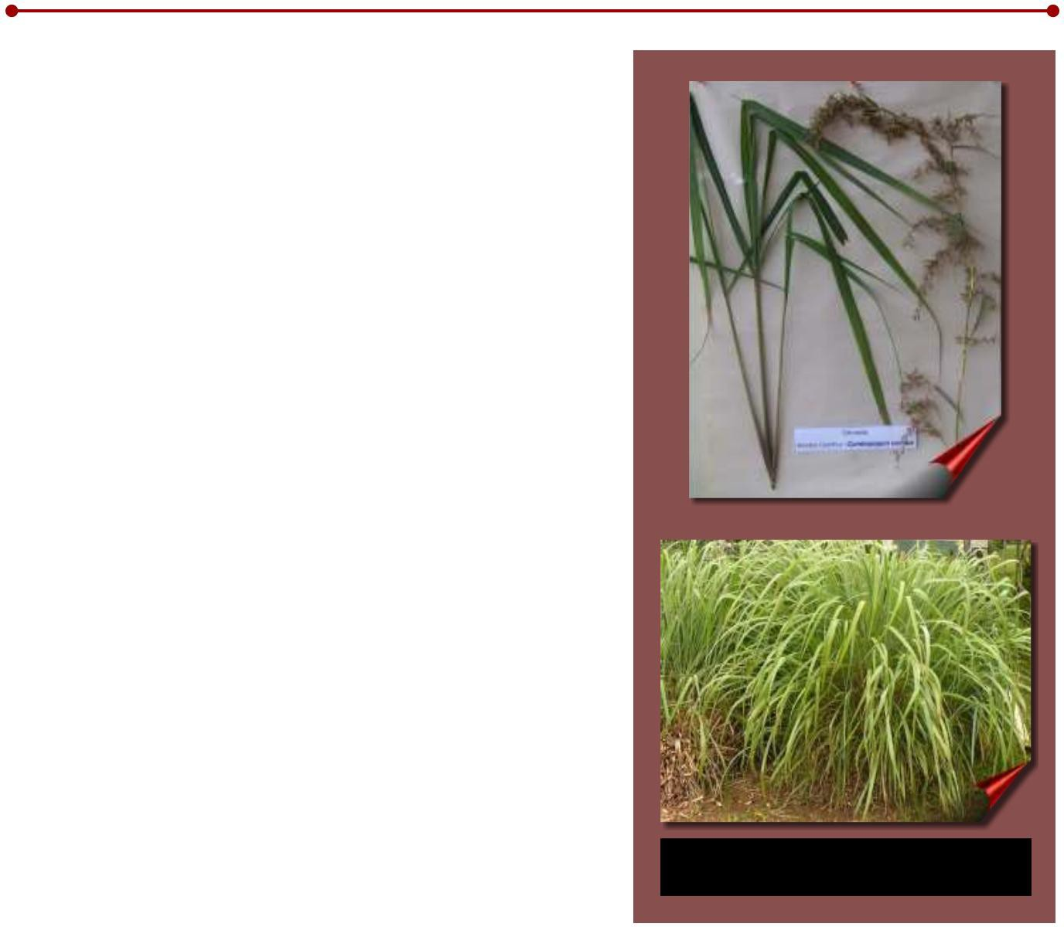
slow, colic and heal wounds (Roig 1988; Barragán 1995).

CITRONELLA

Scientific name: Cymbopogon nardus (L.) Rendle.
Family:Poaceae

It is a herbaceous plant that produces a large number of rhizomes, tillers or children, which are used for its propagation. It can reach a height of up to 2 m.
The leaves are light green, long, wide, smooth and have a strong characteristic lemon smell, a product of the active ingredients that this plant possesses.

Under conditions of tropical humid forest, it produces abundant floral structures, in large brown clusters, however, the seeds are not viable, so their multiplication by suckers or tillers is necessary (Roig 1988).

This plant has essential oils in its leaves, which contain appreciable amounts of Geraniol, which is one of the main products obtained.

The usable part of the plant are the leaves, which can be harvested up to four times per year, depending on the growing conditions (Roig 1988).

The main use given to this species is industrial for the preparation of different products, among which are listed below:

Figure 8. Citronella (Cymbopogon nardus (L.) Rendle).

L Geraniol preparation.
L Perfumery and soap.
L Mosquito repellent, usually in the form of an ointment.
L Insecticides from essential oils. L Flavoring of some insecticides. L Preparation of shoe creams.
L Prepared to clean furniture.

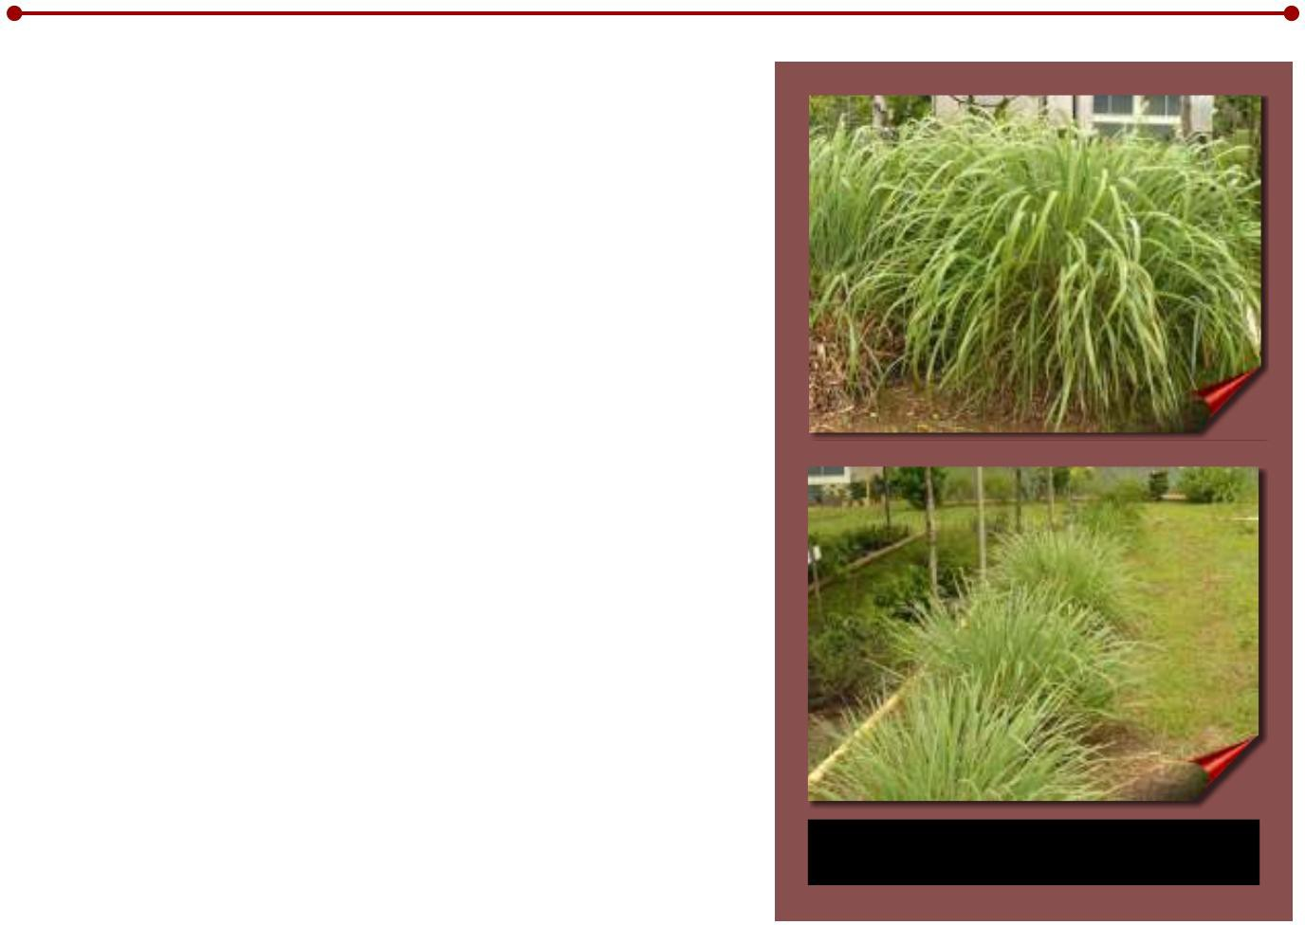
LEMON GRASS

Scientific name: Cymbopogon citratus Stapf.
Family: Poaceae

It is estimated that this species has its origin in Asia and Equatorial Africa.

This species has a short, branched rhizome that gives rise to numerous tillers, which must be cut from the mother plant to extend its useful life.

The leaves are long and flat, pale green, with a sharp edge; the plant reaches an average height of 1 m, depending on the growing conditions;
they have a marked lemon odor due to the presence of an essential oil that contains citral (70-

85%), geraniol, linalool, methylheptenone, citronellal, limonene, dipentene, and other components (Acosta 1995; Roig 1988).

Acosta (1995) reports that this species does not flourish in countries with a tropical climate, a situation corroborated under the conditions of the Experimental Farm Ollas Arriba, so its propagation is carried out using the children or sectioned tillers of the mother plant.
Figure 9. Lemongrass
(Cymbopogon citratus Staff).

The infusion of the leaves of this species is commonly used to improve digestion, although it is also used to relieve cough, flu, headache, fever, nervous states and is hypoglycemic, with some hypotensive properties also being reported. The infusion of this species is highly appreciated for its pleasant taste, to be taken at any time of the day

(Acosta 1995; Roig 1988).

It is important to bear in mind that in order to obtain the infusions from the leaves of this species, they must be placed on filter paper, to avoid the release of silica crystals that are found throughout the leaf, and consumption should be avoided . of these crystals, since they present the risk of accumulating in fatty tissues, thus being potentially carcinogenic (Acosta 1995).

Among other industrial uses, this species is used as a flavoring agent, in addition to being used in the perfumery and cosmetics industry.

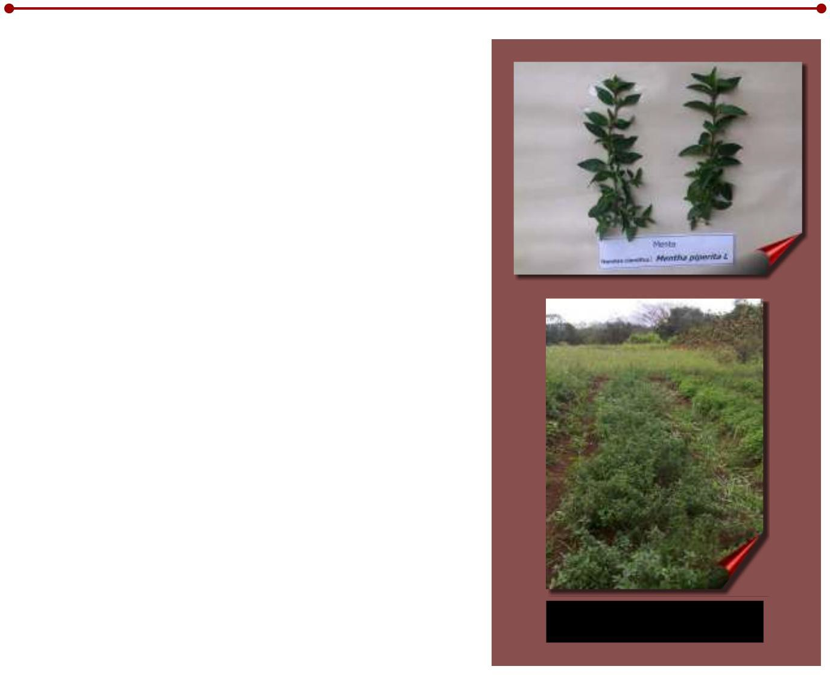
MINT

Scientific name: Mentha piperita L.

Family: Lamiaceae (Labiatae)

There are about 20 species that are recognized as Mint, since they have characteristics that are imparted by the active ingredients present in their system. The species
M. piperita L. comes from the hybridization of Mentha aquatica x Mentha viridis, which originated naturally in England around the 17th century and has been multiplied throughout the world since then (Roig 1988).

It is a herbaceous species, with semi-creeping, quadrangular, highly branched stems, which can reach a height of up to 60 cm. It has opposite petiolate leaves, lanceolate or acute, with sharp edges.
serrated, dark green on the upper face and lighter on the lower. Flowers grouped in dense spikes, purple. The stolons are of section
quadrangular and grow on the soil surface in all directions (Acosta 1995; Roig 1988).

This species can be multiplied by means of seed, herbaceous cuttings or by stolons, which are very abundant when the plant reaches its full development.

Figure 10. Mint
(Mentha piperita L.).

At the beginning of flowering, if the purpose is the production of foliage, the flower clusters must be eliminated to promote the emission of new shoots, since otherwise, the plant tends to die when the seed production stage arrives.

This species is used in traditional medicine as an infusion for the treatment of digestive problems, for which the leaves and flower clusters are used. Stimulating and antiseptic properties are also attributed to it (Roig 1988; Acosta1995).

It is widely used in the medicine, confectionery, liquor and ice cream industries, which use the essential oils that are extracted from this plant.

GUARUMO

Scientific name: Cecropia obtusifolia Berthold
Family: Cecropiaceae

The Guarumo is a tree that reaches a height greater than 10 m, with a straight and hollow stem, with few
ramifications, with large leaves in the shape of an extended hand, dark green on the upper side and silvery on the underside, with petioles about 30 cm long. The flowers are located in dense spikes covered by a spathe-shaped bract; its fruits have a seed. The stem has a thin, smooth, gray bark that, when injured, exhibits a milky sage. Characteristic of this species is the presence of the Prostomas, which are openings that the plant has for the shelter of the ants of the genus Azteca sp.,

that live associated with the plant.

It is a plant that is considered to have properties against diabetes, using the infusion of the leaves, branches, bark or root as water for use. Hypotensive properties are also attributed to it and to treat kidney problems, recommending the decoction of this plant for its ingestion on an empty stomach for at least a week. It is reported quite effective as a pectoral, also for the control of asthma.

Figure 11. Guarumo
(Cecropia obtusifolia Berthold).

In cases of warts, calluses and herpes, the latex of the plant is applied directly to the lesions, and against burns it is recommended to grind the leaf with baby oil or boil them with salt for application in baths or as poultices (Taylor 2005).

GUAVA

Scientific name: Psidium guajava L.
Family: Myrtaceae

Tree 4 to 10 m tall, smooth whitish-brown bark.

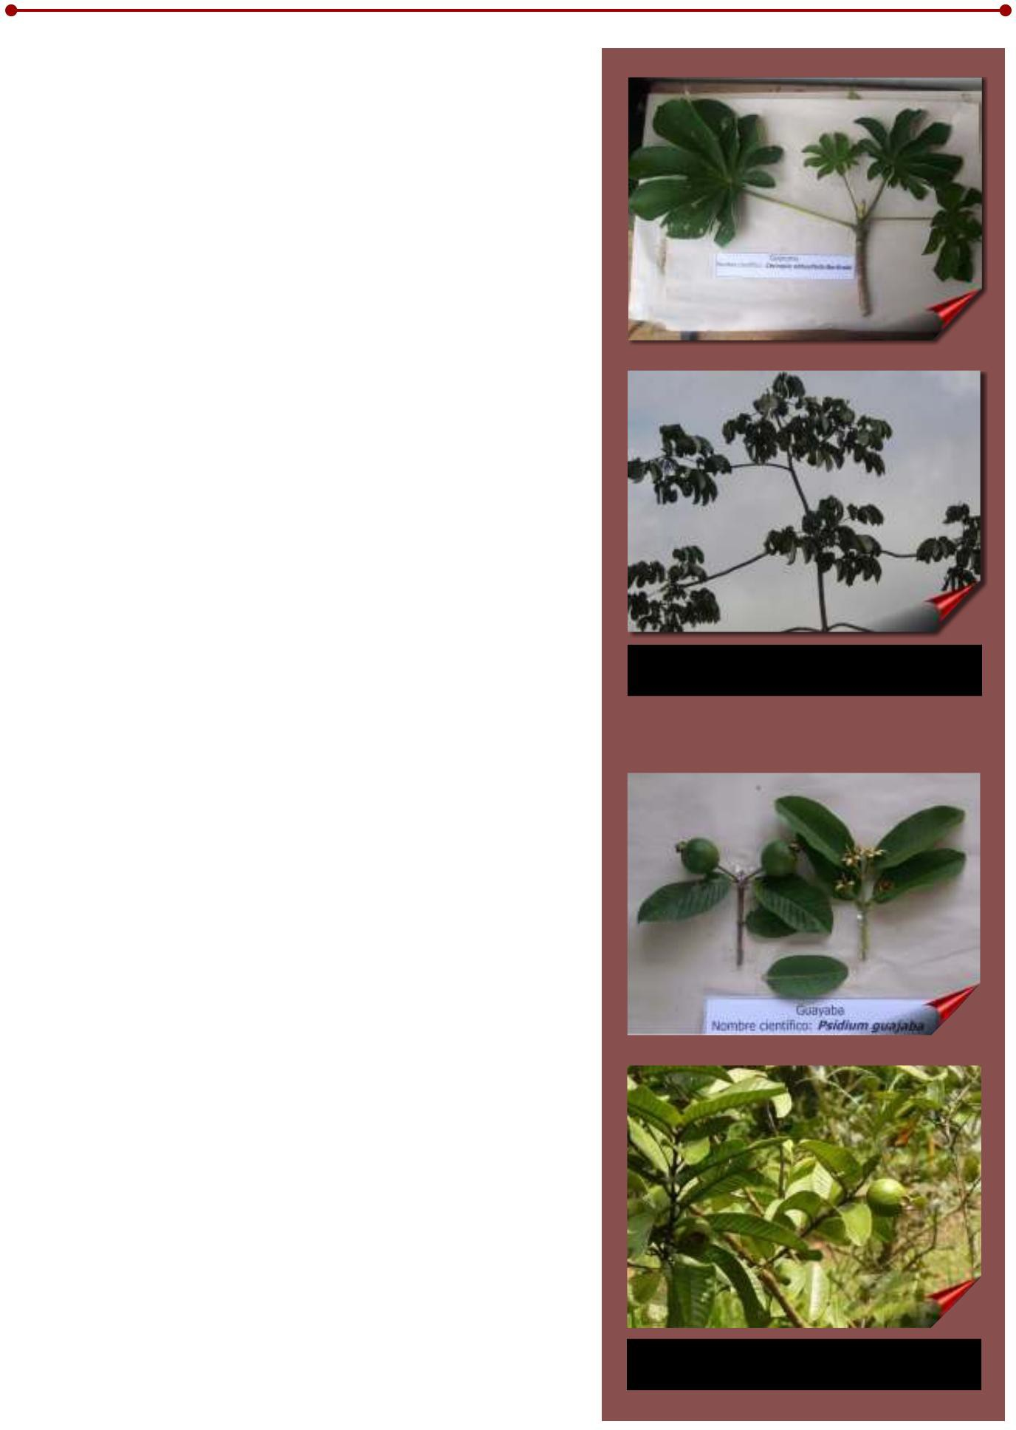
The leaves are simple, opposite, elliptical, hard coriaceous, 4 to 8 cm long with raised veins, pubescent below, with short petiole.
The flowers are large, axillary or terminal, solitary or in a group; white and fragrant petals. The fruit is a berry, of variable size with a large number of seeds and pulp with a sweet taste and characteristic smell,

Figure 12. Guava
(Psidium guajava L.).

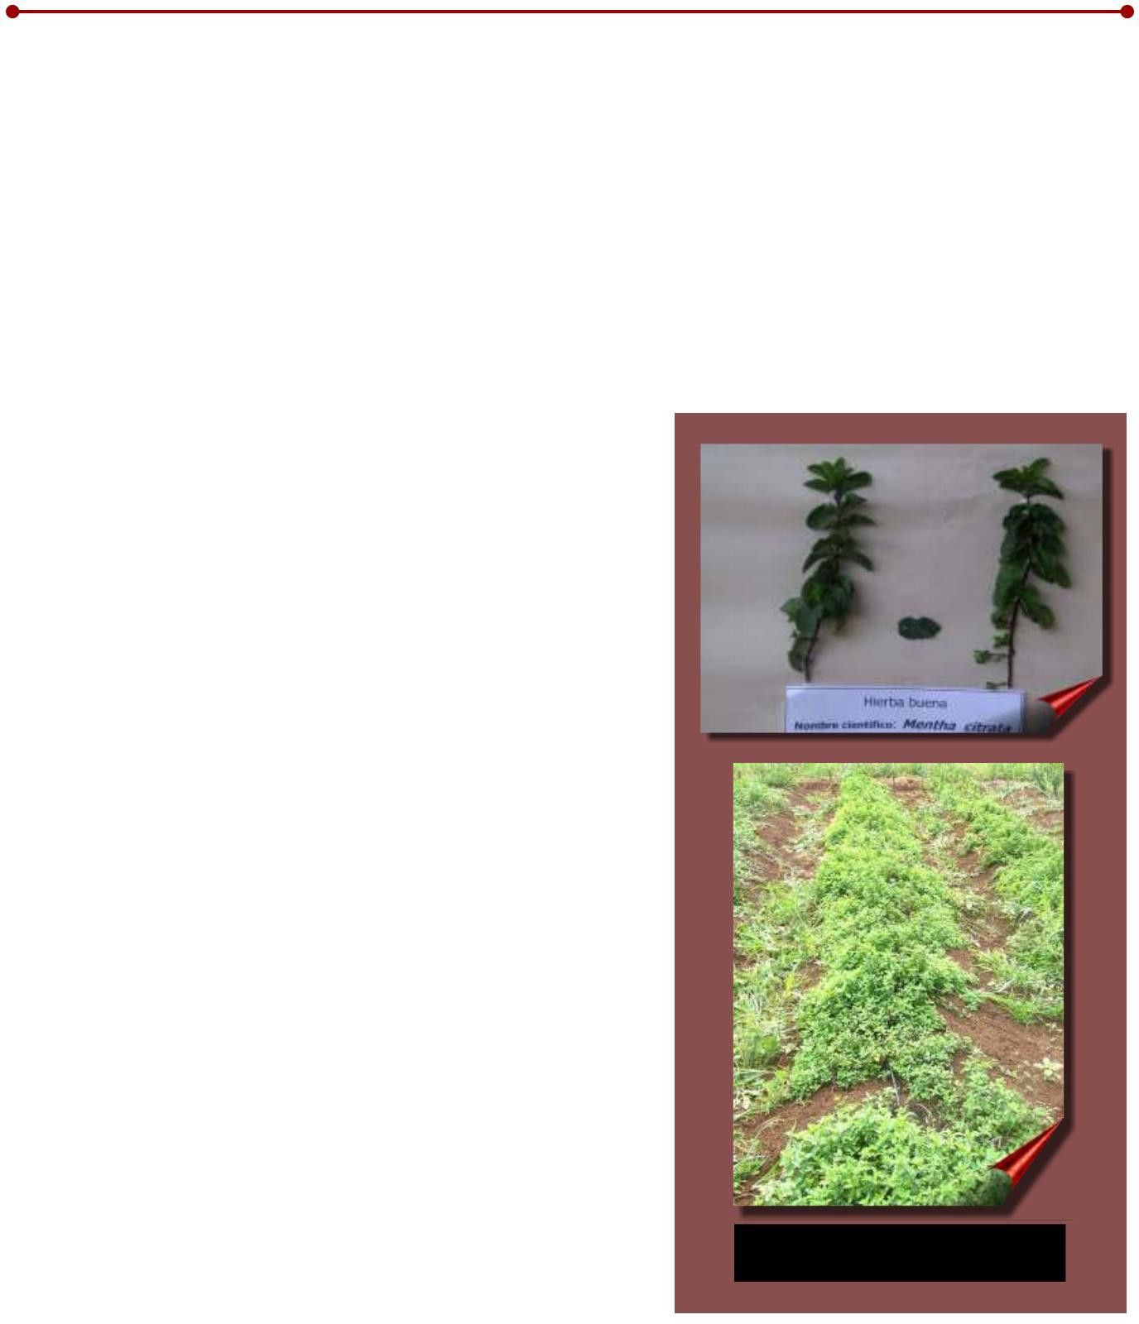
diverse color ranging from white through yellow to different shades of pink, depending on the variety (Roig 1988; Acosta 1995; CETAAR-INCUPO 1997).

This plant has a very old use. It is frequently used in gastrointestinal illnesses such as diarrhea and stomach ache, by infusing the leaves three times a day or as drinking water. In skin problems, the leaves alone or mixed with other herbs are boiled and then applied locally in washes or poultices (Roig 1988; Acosta 1995; CETAAR-INCUPO 1997).

PEPPERMINT

Scientific name: Mentha citrata

Family: Lamiaceae (Labiatae)

It is a creeping herbaceous plant, with reddish stolons and angular branches, with opposite oblong leaves, with short petiole, 2 to 4 cm long, with a wrinkled upper surface with a serrated edge, with a dark green color on the upper surface and paler on the underside, very aromatic when crushed (Roig 1988; Acosta 1995).

Its multiplication is carried out by planting stolons or cuttings from the ends of mature branches, since the emission of floral structures has not been observed in the ecological conditions of the study locality.

It is mainly used for digestive disorders such as heartburn and stomach pain, diarrhea, bile. Another use of the decoction of the branches is to achieve good digestion and relieve stomach discomfort in children. Peppermint, too, is used to expel
intestinal parasites, through an infusion prepared with cooking shoots sweetened with honey and mixed with paico. Another reported use is as a deflamant for the respiratory system in the form of inhalations (Roig 1988; Acosta 1995).

PLANTAIN

Figure 13. Peppermint
(Mentha citrata).

Scientific name: Plantago major L.

Family: Plantaginaceae

The plant reaches a height of 10 to 30 cm; it has large and elongated leaves that are born from a rosette shape on the ground, with a length and width between 28 and 9.1 cm, respectively; it presents an average of 5 prominent ribs, with an inconspicuous presence of lobulations in the form of teeth.
The leaf petiole is 10 to 15 cm long.

eleven

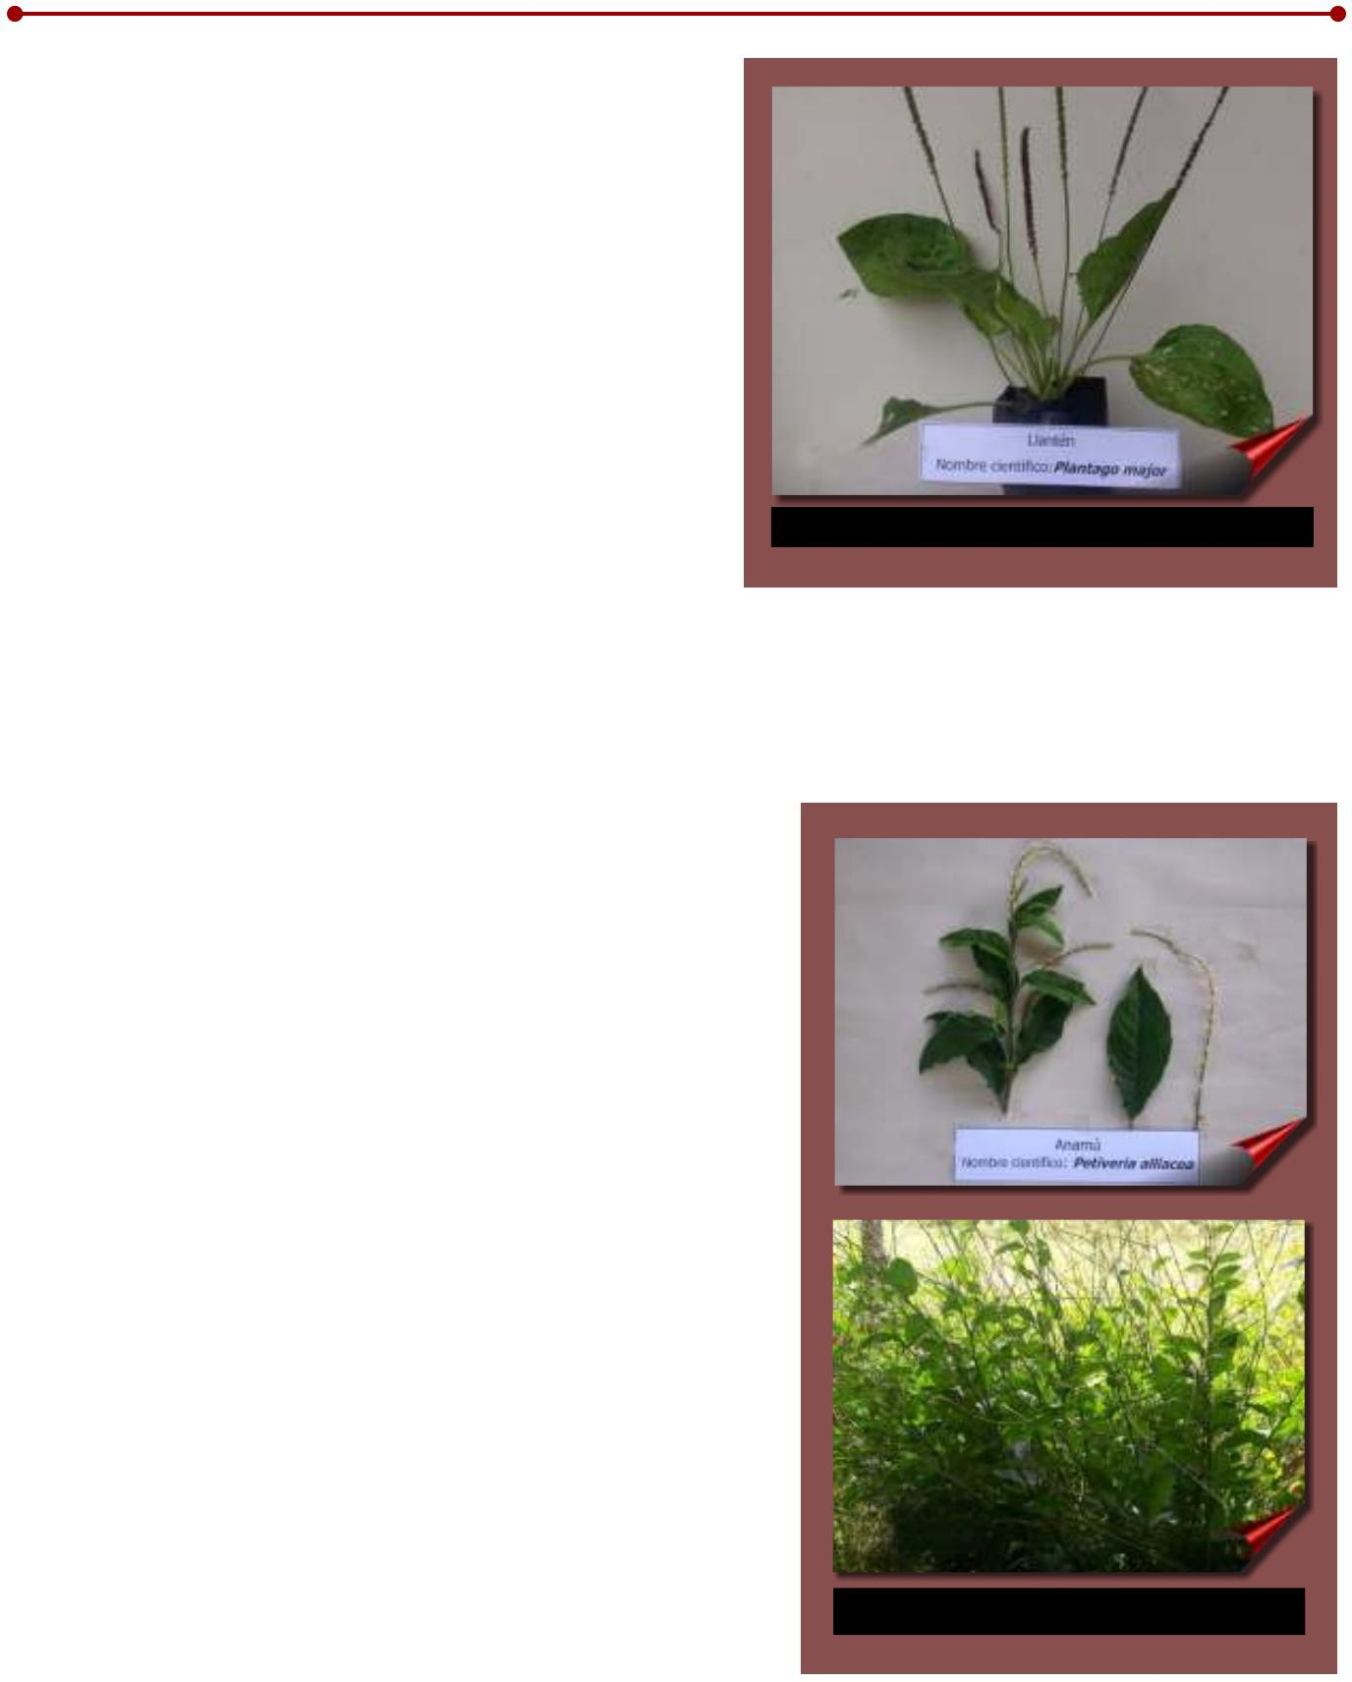
The root system is composed of a group of roots emerging from the same point. The flowers are grouped in inflorescences on a long peduncle, in which the structures that contain the seeds are subsequently formed, which are brown when mature, with a large number of small dark-colored seeds inside (Roig 1988; Acosta 1995).

The leaves and the root are used for digestive and kidney problems due to their anti-inflammatory and analgesic action, for which the infusion of the leaves is consumed as daily water; It is also used to reduce inflammation of bruises, wounds and eyes. In cases of rheumatism, minor injuries, abscesses and bone pain, it

Figure 14. Plantain (Plantago major).

is recommended to use the macerated leaves. Other uses are reported as hypotensive, by ingesting the infusion of the leaves (Acosta 1995; Roig 1988).

ANAMU

Scientific name:Petiveria alliacea
Family: Phytolacaceae

This species is native to the southern United States, being found throughout Central America to Argentina.
In some regions of the country it is known as Zorrillo, due to the strong smell it emits when squeezing the leaves or tender stems.

This is a perennial herb that grows in shady places, woody only at the base, branched, reaching a height of less than
1.50 m, with green herbaceous stems, with alternate, simple, elliptical leaves ending in an elongated point, with two leathery stipules at leaf base. The average dimensions of the adult leaves reach 13.7 cm with a width of 5.3 cm, corresponding to what was reported by Roig (1988).

The flowers are small, greenish-white, arranged alternately in an average number of 32 flowers per spike, which average a length of 35 cm. The fruit is an achene that turns brown when ripe, covered with short hairs that stick tightly to the skin, even causing damage when removed. The size of the

Figure 15. Anamú (Petiveria alliacea).

fruit is 4 to 8 mm. The multiplication of this species can be carried out by means of seed or by sections of the stem.

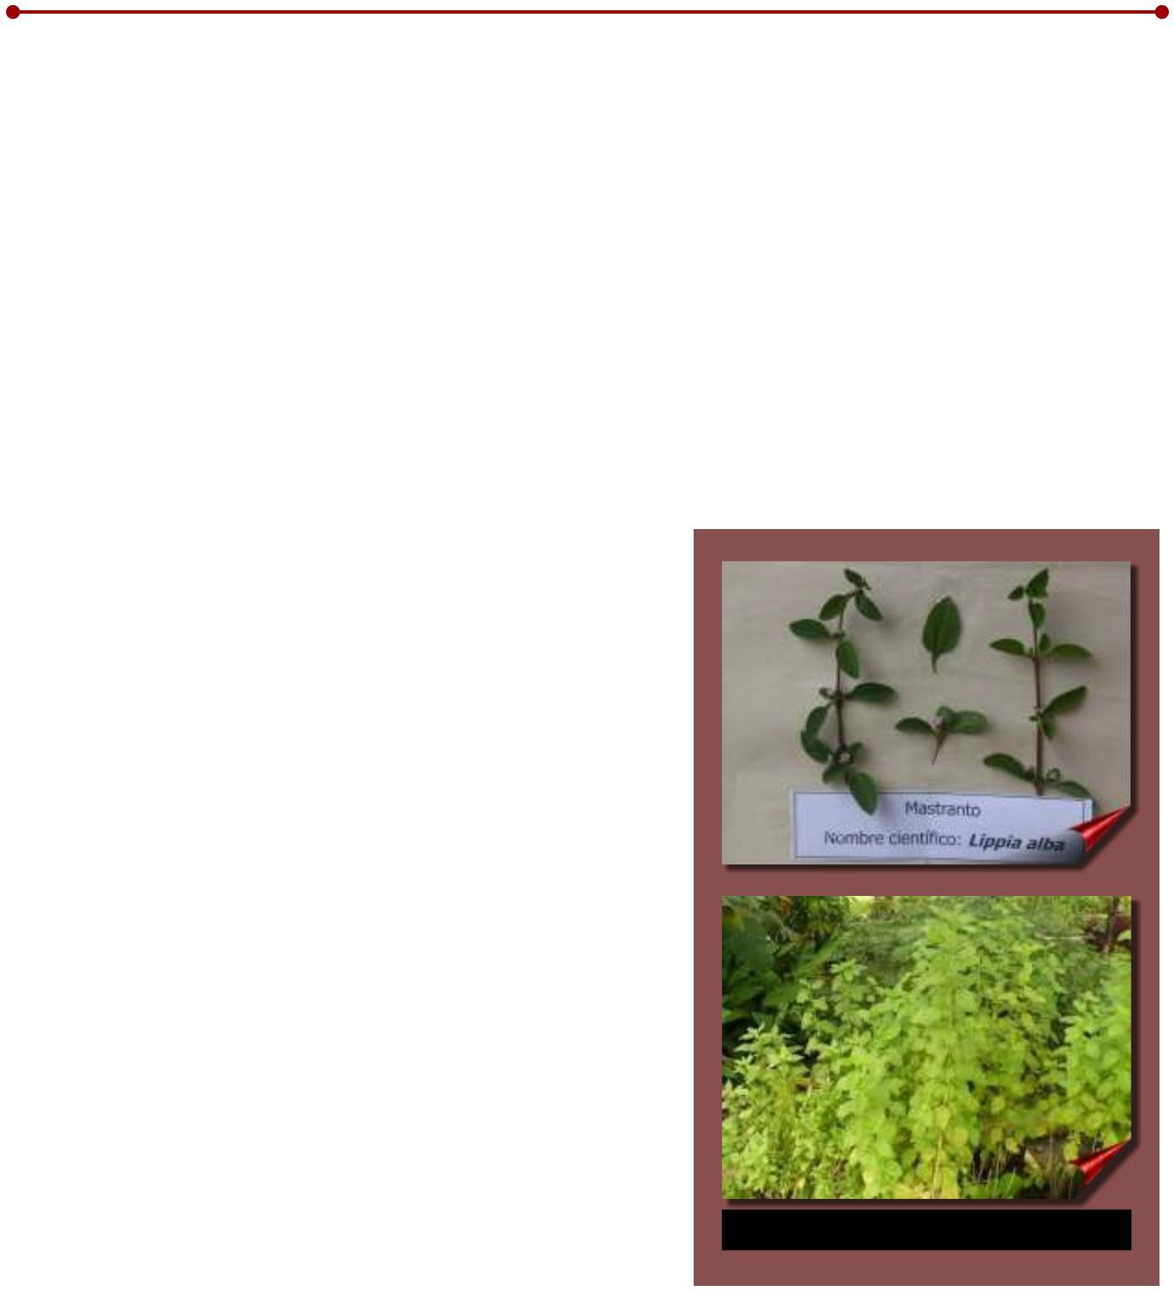
In Panama, it is found in the wild, generally in areas with natural shade on the banks of streams, where it develops satisfactorily.

From this plant the leaves and tender stems and the root are used, being used for the relief of the flu, asthma, cough and bronchitis with the infusion of the leaves.

Its use is reported in the Caribbean islands, as an abortion plant, causing bleeding in women who consume it at the time of menstruation, so it should be consumed with great caution. Its use is not recommended in pregnant women. The use of the powdered root and leaves is recommended for the relief of sinusitis (Roig 1988; Acosta 1995; CETAAR-INCUPO 2005).

MASTRANT

Scientific name: Lippia alba Mill
Family: Verbenaceae.

This species is an aromatic shrub with a height of 1.0 to 1.5 m, very branched, with angular stems, with leaves opposite in number from 2 to 4 for each node, abundantly hairy on the underside, finely serrated, with short petioles. , rough on the upper side.

The flowers are small, located in
axillary inflorescences, covered by bracts; the corolla is lilac with a yellowish center (Roig 1988; CETAAR-INCUPO 2005).

Its multiplication is done by cuttings, since it has a great regenerative capacity.

It grows very well in Tropical Humid Forest conditions.

The reported use for this species is as digestive and relief of stomach discomfort, for which the leaves and tender stems are used in infusion. Its use is also reported for the relief of flu, colds and expectorant (CETAAR-INCUPO 2005).

Figure 16. Mastranto (Lippia alba Mill).

ROSEMARY

Scientific name: Rosmarinus officinalis L.
Family: Lamiaceae (Labiatae)

It is an aromatic bush, branched, it can reach up to 1.0 m or more in height, depending on the development conditions, of an evergreen color, with filiform leaves composed of 4 to 5 leaflets, linear, narrow and opposite, green in color, with a certain curling. to the reverse. The stem has short internodes at an approximate distance of one centimeter (Acosta 1995; Roig 1988).

The flowers are small and appear in axillary groups, white-pink, bilabiate, with bracts.
In the observations made on the farm
Experimental Pots Above, the flowering of this species has been observed, however, it has not been possible to obtain seeds, so the propagation has been carried out with the use of cuttings from the ends of the branches.

This species has multiple uses in medicine, industry and cooking. Among the most common medicinal uses, the following stand out: relieve disorders of the
digestive, stomach pain and indigestion; It also works for the gallbladder, ulcers, diarrhea, gastritis, colic and the appendix.

It is used in baths against sinus problems, chronic colds and other respiratory ailments.

The decoction of the rosemary branches is also used to prevent hair loss and against skin conditions. It is used in poultices for muscle pain, back pain, hip pain, bone pain; bumps, rheumatism, joint inflammation and fluid retention (Sisa 2004;Roig 1988;Acosta 1995).

Figure 17. Rosemary (Rosmarinus officinalis L).

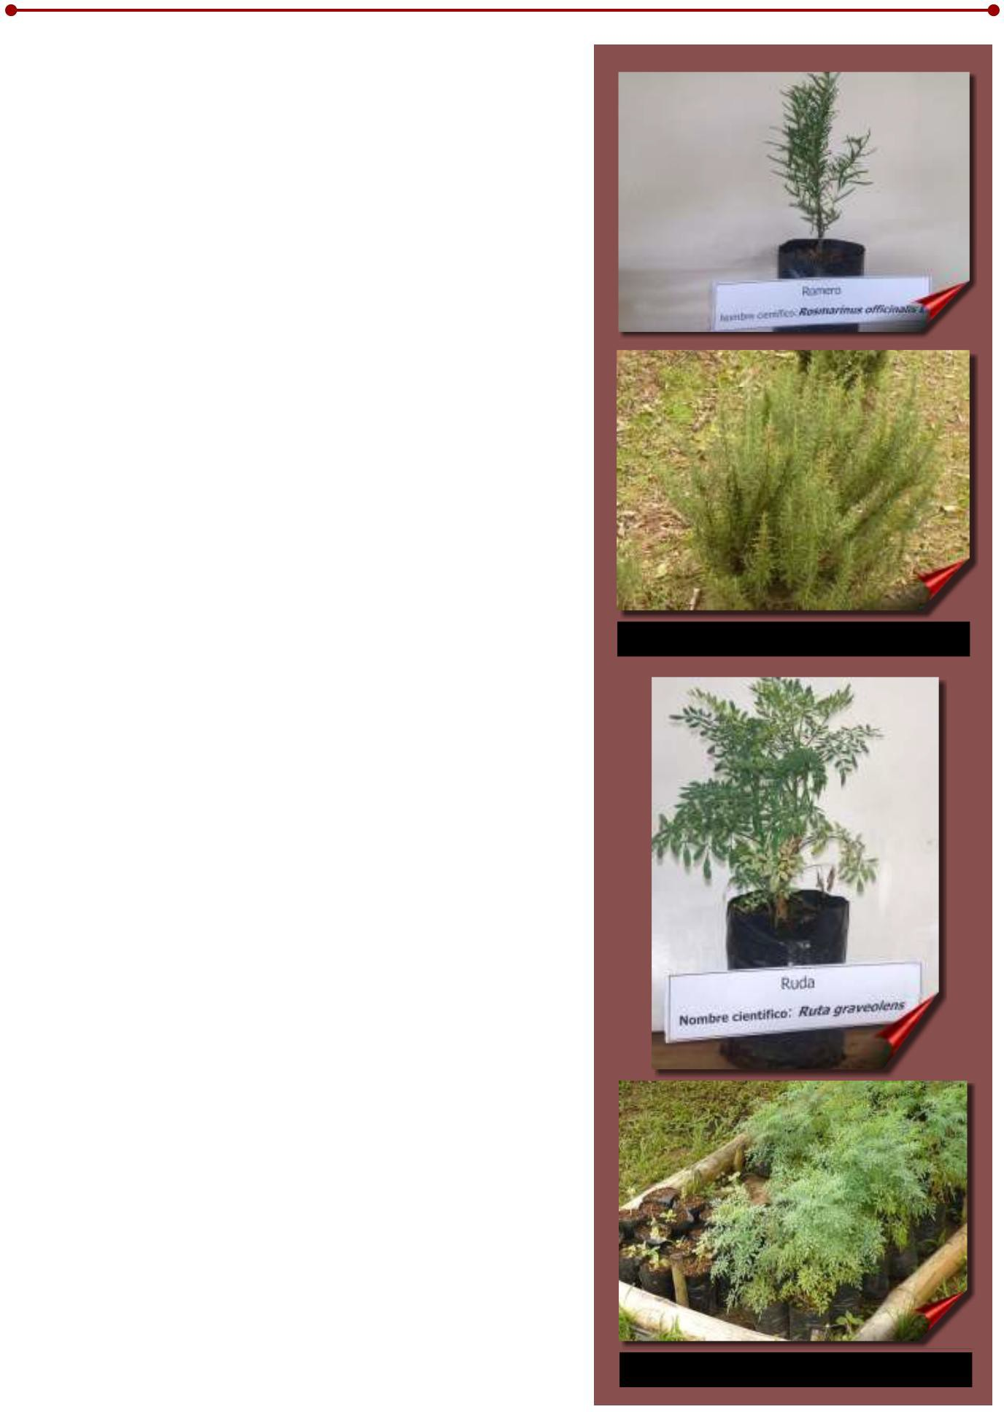

RUE

Scientific name: Ruta graveolens
Family: Rutaceae

Herbaceous plant 30 to 60 cm tall, with hairless stem and leaves.

This plant emits a strong unpleasant odor, with rounded stems, greyish- green foliage. The leaves are alternate, pinnate, petiolate with an average of 8 leaflets and 6 to 7 leaflets. Flowering has been observed in this species, with yellow flowers that are organized in

terminal inflorescences (Acosta 1995; Roig 1988; Barragán 1995).

One of the uses attributed to this species is to relieve ear pain by depositing one or two drops of the plant juice extracted after heating the leaves (Barragán 1995). This plant should be used with caution, mainly in pregnant women, since some of its principles have anti- inflammatory action.
Figure 18. Rue (Ruta graveolens).

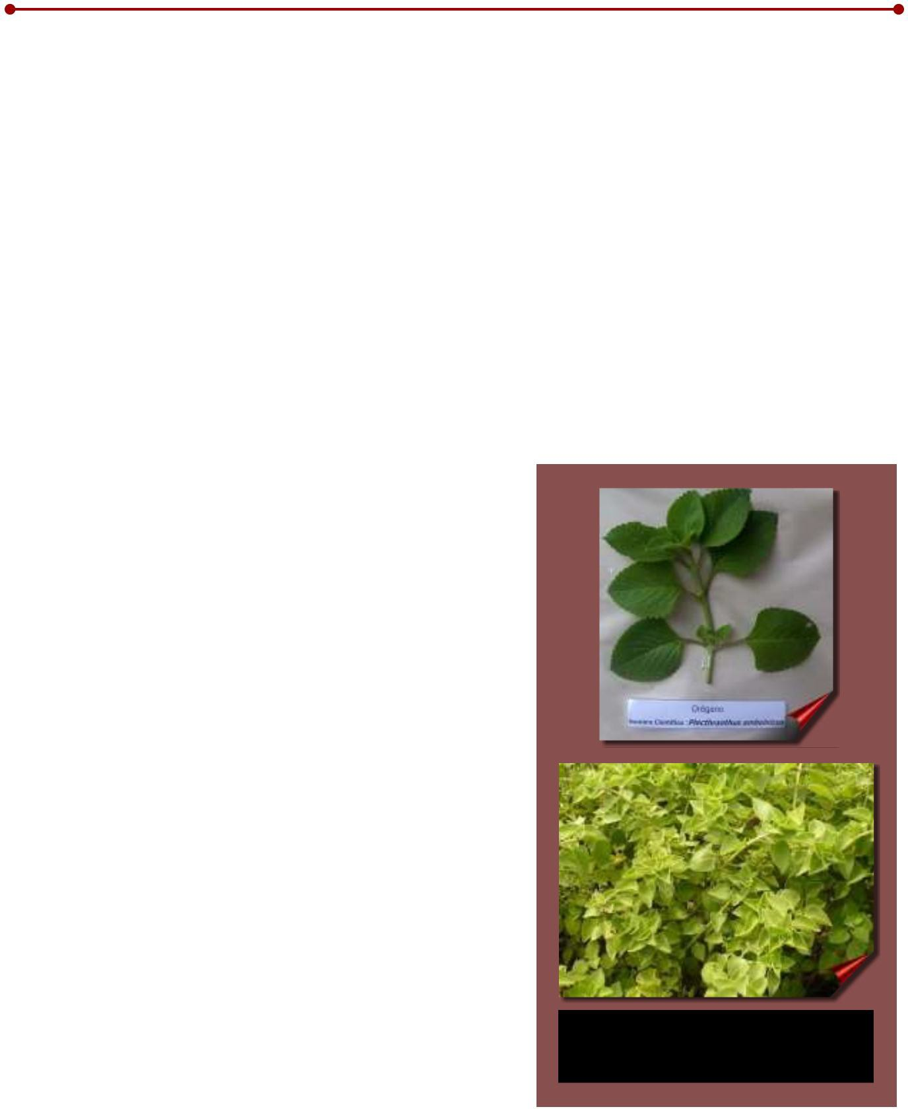
abortive. Cardiac activity is similarly attributed to it (Roig 1988; Acosta 1995).

Likewise, drinking three cups a day of an infusion made with three rue leaves per liter of water is useful against nervous diseases, dizziness, headache, rheumatism and gout. Rue is also for external use and is used to clean ulcers, sores, for mouthwash and as a lotion to massage the scalp twice a week to eliminate lice (Barragán 1995).

Spiritual properties are also attributed to this plant, which is why it is used in cultural rites in different places.

OREGANO

Scientific name : Plethranthus amboinicus (Lour) Spreng Family: Lamiaceae (Labiatae)

It is a herbaceous plant with angular, very fragile stems that can reach up to 1.0 m in height. The leaves are simple opposite and alternate, with average dimensions of 15 cm long and 8.0 cm wide, oval, fleshy, toothed, densely hairy on the upper and lower sides, with a thick petiole, truncated at the base, which give off an odor. strong characteristic of the plant.

In the axils of the leaves there are meristematic buds that give rise to secondary branches, which allow the growth of the plant.

No flowering of this species has been observed under the prevailing ecological conditions in the area, which correspond to the Tropical Humid Forest life zone.

This plant is propagated by cuttings from the ends of the stem, preferably from plants
fully developed.

The uses in traditional medicine are as a bronchial dilator, expectorant and anticatarrhal, consumed as an infusion
of the leaves. It is also used in traditional cooking as a condiment.

Studies carried out in Cuba indicate the potential of essential oils obtained from this plant for use as an anticonvulsant (Acosta 1995).

Figure 19. Oregano
(Plecthranthus amboinicus
(Lour) Spreng).

fifteen

CONCLUSIONS

Based on the information obtained in the development of the project, the following can be concluded:

jThe diversity of the Panamanian flora admits the possibility of increasing the number of species declared with medicinal properties.

j There is a significant number of botanical families with representative species with medicinal properties.

j The scientific literature available with information on the pharmacological and therapeutic properties, characterization and botanical classification of medicinal species used in traditional Panamanian medicine is limited.

j It is necessary to develop more research for the identification and characterization of medicinal plants that are used by the population at the national level.

BIBLIOGRAPHY

ACOSTA, L. 1995. Give yourself health. Grow medicinal plants. Havana, Cuba. Scientific-Technical Editorial. p. 227.

BARRAGAN, S. 1995.a Aloe. (online) Unknown Mexico. No. (217). Accessed 3 Aug. 2006.
Available at http://www.mexicodesconocido.com.mx/espanol/index.cfm.

BARRAGAN, S. 1995.b Rue. (online) Unknown Mexico. No.(219). Accessed 3 Aug. 2006.
Available at http://www.mexicodesconocido.com.mx/espanol/index.cfm.

Cymbopogon citratus Stapf. 2008. Accessed 12 Dec. 2008. Available at
http://www.herbotecnia.com.ar/index.html .

CETAAR-INCUPO (Center for the Study of Appropriate Technology of Argentina, Institute of Popular Culture). 1997. Medicinal Plants of the Argentine Northeast. Popular wisdom and scientific validation. Buenos Aires, AR. 149 pages

FRANCIS, J. 1990. Hymenaea courbaril L. Algarrobo, Locust. US Department of Agriculture, Forest Service, Southern Forest Experiment Station. 5 p.

Aloe, Sabila, Aloe barbadensis Mill. 2006. Accessed 12 Dec. 2008. Available at
http://www.herbotecnia.com.ar/index.html

Citronella. Cymbopogon nardus (L) Rendle. 2006. Accessed 12 Dec. 2008. Available at
http://www.herbotecnia.com.ar/index.html

HERNANDEZ, W. 2001. Family botanical kit (part 2). Medicinal plants of Panama, No.2, year 1. Panama. p.19

LUGO, Z; TUA, D; NAVEDA, M. 2005. The cultivation of Aloe Vera in Venezuela and production costs
for acíbar. (online) CENIAP TODAY. Accessed 19 Nov. 2008. Available at www.ceniap.gov.ve/ pdb/RevistasTecnicas/ceniaphoy/articulos/n7/arti/lugo_z/arti/lugo_
z.htm

Mint, Mentha piperita L. 2006. Accessed 12 Dec. 2008. Available at
http://www.herbotecnia.com.ar/index.html .

NAVARRETE, N; ORELLANA, M. 1998. Hymenaea courbaril: the flour tree. Fact sheet, Fact, 98- 06.Sep. 1998. Forest Farm and community tree Network. (FACT-NET). Morrilton, Arkansas US. 1998. Re,trieved 19 Nov. 2008. Available at
http://www.winrock.org/forestry/factnet.htm

Plantago major. L. 2006. Accessed August 9, 2008. Available at http://www.mexicodesconocido.com.mx/espanol/miniguia/index.cfm .

ROIG, JT. 1991. Medicinal, aromatic or poisonous plants of Cuba. 2nd ed., Ministry of Culture. Volume 1. Havana, CU. Scientific-Technical Editorial. 475 pages

ROIG, JT. 1991. Medicinal, aromatic or poisonous plants of Cuba. 2nd ed., Ministry of Culture. Volume 2. Havana, CU. Scientific-Technical Editorial. 650p

SISA, J. 2004. Rosemary (Rosmarinus officinalis). (online). Ecoaldea.com Accessed 9 Aug. http://

2006. Available at
www.ecoaldea.com/plmd/plantas.htm .

SOTO, HM. 2007. Antioxidant activity of flavonoids from the stem of Mexican oregano (Lippia graveolens
var. Berlandieri Schauer). Mexican Phytotechnics Magazine, January-March, 2007/vol 30, No.
- Chapingo, MX. Mexican Society of Phytogenetics AC p. 43-49

TAYLOR, L. 2005. The healing power of forest herbs. (online). Taken from Raintree nutrition. Tropical Plant Database. Database file for Embauba (Cecropia sp.). Accessed December 22, 2009. Available at .

ZACATE, L. 2006. Cymbopogon citratus Stapf (online). Retrieved 9 Aug. 2006. Available at
http://www.mexicodesconocido.com.mx/espanol/index.cfm .

Technical Brochure

MEDICINAL PLANTS COLLECTED IN PANAMA

It is a publication of
TECHNICAL REVIEW COMMITTEE
Ismael Camargo Buitrago, Ph.D.
Luisa Martínez Rodríguez, Agro Engineer. Julio Alberto Lara Martez, M.Sc Miguel Angel Sarmiento E., M.Sc.

TECHNICAL REVIEWERS
Jorge O. Aued H. PhD
Carmen Y. Bieberach Forero, M.Sc

EDITING
Magdalena Justavino, M.Sc.
Neysa Garrido, M.Sc.

COLLABORATION
Betty Rodriguez

DIAGRAM
Gregoria Hurtado

PHOTOGRAPHS
IDIAP Archives

PRINT
Publications Department Central Level, Panama

“ GENERATING TECHNOLOGY AND INNOVATION FOR AGRICULTURAL PRODUCTION ”

